1. 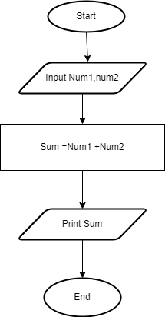Arithmetic operation(sum of two numbers)

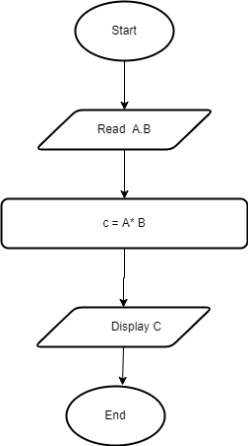

Arithmetic operation(multiplication of two numbers)

**Decision making (Odd even number)**

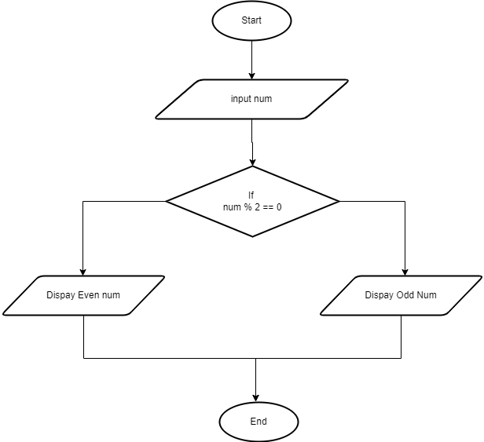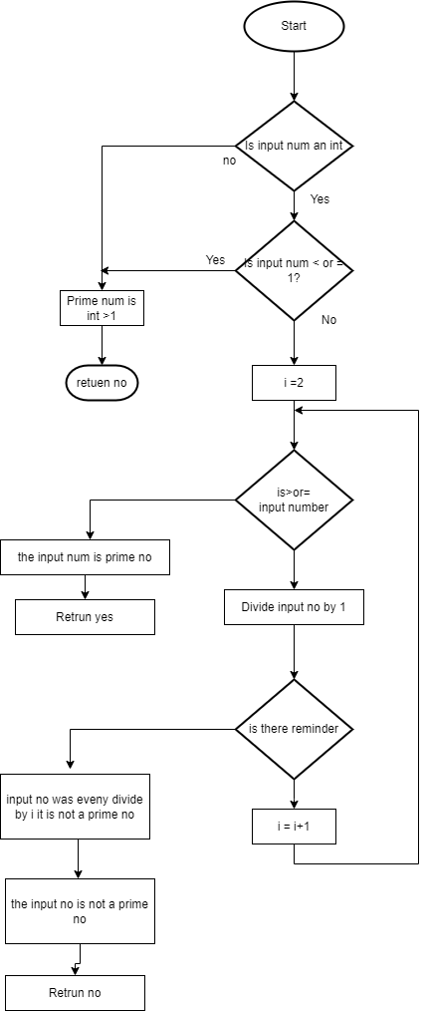

**Decision making (prime a number)**

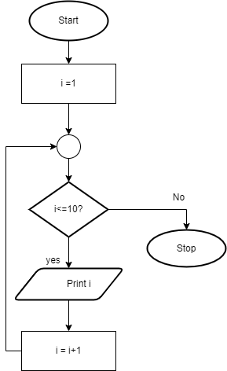

**Looping (print 1-10 No)**

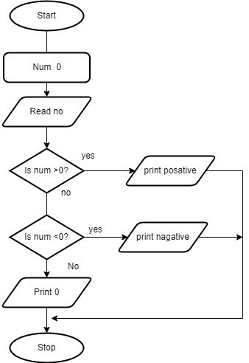

**Looping 2(Positive Negative and )**